“Who Dunked You?”
1 Corinthians 1: 10-18
Rev. Jody Andrade
January 26, 2020

Raise your hand if you’ve seen some form of a “unity” ritual. An example is at a wedding: a member of one family lights a candle, a member of the other family lights a candle, and then the bride and groom use those family candles to light a unity candle. This symbolizes the joining together of two families into one.
I once attended a wedding where the mother of the bride processed into the church, lit the family candle and took her seat. Next, the mother of the groom nervously processed up the aisle and stepped up on the chancel to light her family’s candle. She picked up a match, ran the match head along the striker, one, two, three times . . . but no flame. Embarrassed, she turned to the groomsman escorting her and gave him a panicked look. He wanted no part of this developing fiasco and gently shrugged his shoulders. She tossed aside the first match and picked up a new one. Again, she tried to light it, once, two, three, four … but no flame.
Everyone in the church was collectively holding their breath for her. It was then that the exasperated mother of the groom spit out a four-letter word that was not “Amen.” This word had never before been said inside this church. In fact, I don’t think that four letter word had been said in the parking lot. And because the groom’s mother was a bit hard of hearing, she said that four letter word LOUDLY. Glancing over, I saw a look on the organist’s face that was one for the ages.
I hope the wedded couple, who remain united, get a good laugh every anniversary when they watch (and listen!) to the video recording from that day.
Coming together, uniting, is not always seamless or without challenge. But when there is something vital, some life-giving force that pulls you together, it’s certainly easier. The excitement, the energy, the hope of building something greater than the sum of its parts, has a binding power. When there is a singular, shared goal, a group of people can work well together.
While individuals can have a rich spiritual life all by themselves, following Christ is a team sport. God calls us to come together and be the church. Jesus said, “For where two or three are gathered in my name, I am there among them.” And so we unite, many followers of Christ, together as a church.
As challenging as it can be to come together, staying together, remaining united, takes the real work. Keeping sight of a singular purpose is difficult. We hear in today’s scripture that though the church of Corinth is young, not 50 years removed from the life and ministry of Jesus, it is already splitting. The members are getting distracted from following Christ and only Christ. These new Christians are wandering away from worshiping God, just like the freed slaves of Egypt who turned from YHWH to worship the golden calf. The Corinthians are claiming new allegiances, just as the disciple Peter did when he denied Christ three times before the rooster crowed.
Well, that church in Corinth certainly couldn’t have been a Presbyterian church. We Presbyterians all get along with one another perfectly, right? WE would never get side-tracked and disagree, much less argue among ourselves!
This is a graphic of the history of the divisions and reunions within the Presbyterian church.
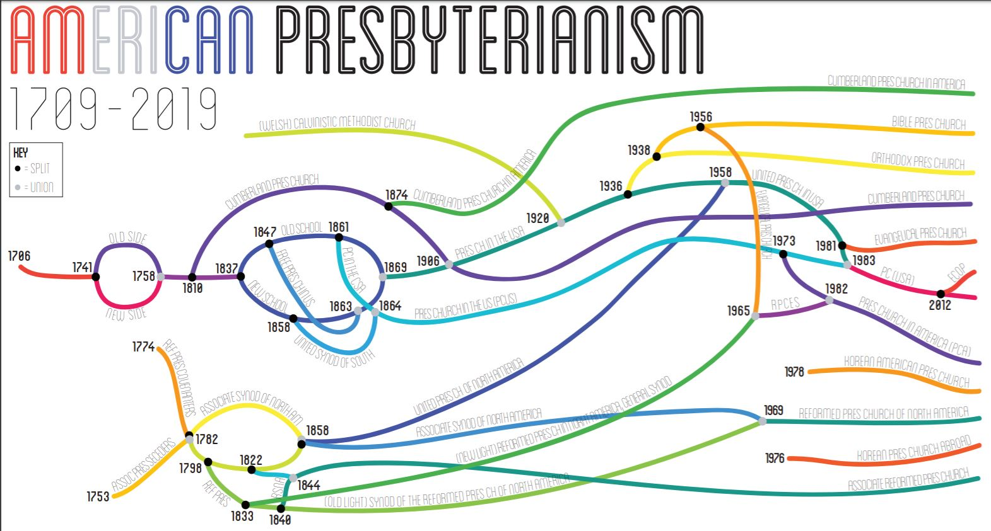
Despite Paul’s advice, we’ve parted ways over many things: revivals, formal education requirements, slavery, abstinence from alcohol, involvement in civic activity, liberalism (female leadership) and LGBTQ issues. Take special notice of 1973. We’re all grateful the PC(USA) saw men and women as equally equipped for leadership: if that hadn’t happened, this church wouldn’t have any preachers!
Here’s the interesting part: we all think we are following Christ as we declare what is right for our church. But sometimes church goers get in our own way. We are human. We can be selfish and power hungry. We think we must be right at all costs. Or we want to remain comfortable, and to keep things “the way they’ve always been.”
When we look back, it’s clear to see when our human mistakes have gotten in the way of the church following Christ. An obvious example is when the Presbyterian church split over slavery. Some church members truly believed that strict adherence to scripture, to the several verses that seem to condone slavery, was the most important issue in the room. Now we know their human greed and desire to maintain the status quo blinded them. Christ’s overarching command to love our neighbor is far more powerful than a few verses written in a different time, in a different context.
But it wasn’t so obvious then.
Which begs the question: to what are we clinging now that is getting in the way of following Christ? What allegiances to individuals, to earthly things, to “the way we’ve always done it” are keeping us from seeing our work as a church through the singular lens of the cross?
In Paul’s letter to the church in Corinth he cites the sacrament of baptism as an excuse for division. People baptized by Apollos want to do things Apollos’ way. Those baptized by Cephas back his agenda. To all of these arguments, Paul says “No!” It does not matter who dunked you in the waters of baptism. As much as Rev. Jennie Sankey, Rev. Susan Haynes and I love (really love!) to baptize, we recognize our secondary role in the sacrament. We are just a small part of a ritual that is an outward sign of an invisible grace. Baptism is about God’s claim on you. In baptism you are cleansed in the waters of redemption and salvation. You have put on Christ and it is in HIM (and only HIM) you have been baptized.
As we move forward into a time of new leadership at Pleasant Hill Presbyterian, we all must remember that together as a church we follow one and only one name: Jesus the Christ. Don’t let phrases like “Jody doesn’t think it will work” or “Jennie did not suggest this” ever get in the way of the Holy Spirit moving through this place. We are called to FOLLOW Christ. Not stand in the same place where we’ve always stood or do things the way we’ve always done them. To follow means you’ve got to get up off of your seat and act. We’re called to move in new ways, interact in the world differently, and always, without fail, ensure our church’s mission aligns with the view we see through the cross.
Christ calls us to look at the world as God sees it. Respect the grandeur of nature rather than depleting it. Embrace the diversity of humanity rather than fearing it. Explore the mystery of individual choices instead of insisting on a blind following of “the way things have always been.”
Paul says, “For Christ did not send me to baptize but to proclaim the gospel….” That’s true for me as a minister. It’s also true for all of us. Paul tells us as a church to keep our eyes steady: to spread the news of the gospel. Jesus Christ has come to the world to save us, so we may live fully, using all of our given gifts for good. It’s a simple message that can get lost in committee meetings, worship order, and office hours. It seems the more fancy the polity and the bigger the words, the further we might stray from the only truth that matters: Christ came to this world not to condemn it, but to save it. All of it.
Paul continues, “…[A]nd not with eloquent wisdom so that the cross might not be emptied of it’s power.” Not with eloquent wisdom. That is, don’t let this church, or your own Christian life, get derailed by fancy words or warring factions. We look to the cross for everything. We see his willing sacrifice and immeasurable love and we are to go and do likewise.
We need this church. It’s a place to recognize God in one another and for others to see God in us. It’s a community dedicated to rolling up our sleeves and doing work to help usher in God’s kingdom. Work like Operation Turkey Sandwich. The Lil’ Pantry. Confirmation partners. Inspired music. Creation of the Prayground.
The Holy Spirit rolls through this place and we become the hands and feet of Christ. We, together as a church, are the body, and Christ is the head.
I’ve shared this story with you before, but it bears repeating. When my daughter Grace was 4, she was the kid who sat right next to the preacher during the children’s sermon. One Sunday during Advent, Rev. Jim Cantrell used a small candy cane to illustrate a point. Candy canes are shaped like a “J” and he was hoping the children would understand that Christmas isn’t about candy or Santa; Jesus is the reason for the season. Rev. Cantrell held his microphone in one hand and the candy cane in the other and said, “Who knows what letter this looks like?” Grace’s hand shot up and the pastor handed her the microphone. “J!” she said joyfully. “And what does “J” represent this important time of the year?” the pastor asked. Grace, with a triumphant look on her face replied “J . . . is for JODY!”
Make no mistake about it: at this church, “J” is not for Jody. Or Jennie. J is for Jesus. We don’t pledge our allegiance to our elected leaders, the Session. We don’t align ourselves with one pastor or another. And we won’t try to garner special favor with the new pastor headed our way.
We follow Jesus. And when we do that as one congregation, one denomination, one greater church, one world, we know that the fullness of God’s kingdom draws near. If we look only through the lens of the cross, we are assured to be living our fullest, best lives in service to Him. Until he comes again. Amen.

Matthew 18: 20, NRSV
Exodus 32.
Matthew 26.
https://kingha.us/blog/a-visual-timeline-of-american-presbyterianism-1709-2019?fbclid=IwAR3LOlqrmoKhD5vHprBKYfUqTzgZx8PseJog9tfqNBLdxUr_oHcoiMtUsqs

