“Faces of our Faith: the Ethiopian Eunuch”
Acts 8: 26-40; Romans 5: 1-5
Rev. Jody Andrade
May 2, 2021

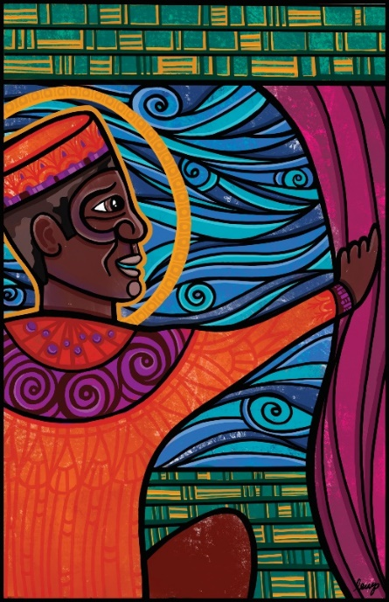

“I want to be the eunuch!” said no kid ever at Vacation Bible School. “I’ll be a shepherd! I’ll be a king! I’ll be Mother Mary!” yes. But no one raises their hand and begs to be the eunuch.

To me, being the eunuch sounds pretty good. Do you want to be from an exotic, foreign land or from...say…”Snellville…where everybody is somebody?” Do you want to work in the palace or under fluorescent office lights? Do you want to lounge on gorgeous fabrics while four men carry you from town to town or do you want to jump on the bus? The eunuch is in charge of the treasury. The eunuch serves the queen. The eunuch has no kids to feed, no spouse to please, he returns home at the end of the day to dine on bon bons and watch Netflix uninterrupted. On paper, aside from just that one thing, the eunuch’s life looks pretty fabulous.

Not only is his life posh, but the eunuch is courageous. He travels on a dangerous road to a foreign land to sit beside people who look wholly different from him to worship a God he does not understand.
Posh on the outside, courage on the inside. But wait, there’s more. The best part yet. The eunuch has the humility to admit he doesn’t have all the answers. Wouldn’t it be a relief to go through life without posturing and pretending? The eunuch asks a stranger, Philip, to explain the scripture he is holding in his hands. And then he trusts - he believes! - what the stranger Philip tells him!

Diana Butler Bass says walking the way in trust (journeying down the wilderness road) and expecting surprise along that way (admitting you don’t know it all) is called…faith. So yeah, I want to be the eunuch. Or at least like the eunuch. I want to be wide open, full of faith, optimistic. “Look, there is water! What is to prevent me from being baptized!”

I felt a deep sense of optimism on Easter morning. There were big, grand reasons for optimism:

- A trumpet, two trombones, six safely spaced singers singing sacred songs.
- The Good News—the Very Best News proclaimed that Christ is risen! (Christ is risen indeed!)
- A crowd of joyful people, together and safely apart, proclaiming victory of life over death in the face of a pandemic.

And there were smaller, sweet reasons for optimism:

- The variety of birds singing at the 7am service, providing us with a proper worship prelude.
- There was the delightful crackle of the new communion bread wrappers holding homemade challah, the bread of life.
- I noticed Cordell and Robin Prater holding hands throughout the entire 11am service.
- The wooden cross was layered => the wood was covered with prayers during the season of Lent, and then the prayers were covered, layer after layer, in celebratory flowers, from people’s yards.
- The Dannemiller boys -Liam, Alex and Devin the Dad wore matching outfits to celebrate Easter and Matthew Christopher’s baptism. Look, there is water! What is to prevent Matthew Christopher from being baptized?
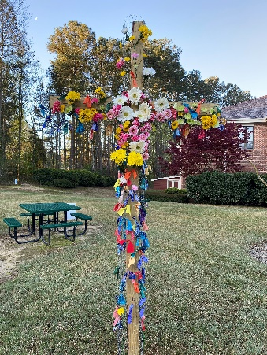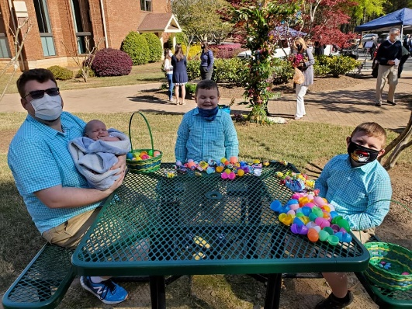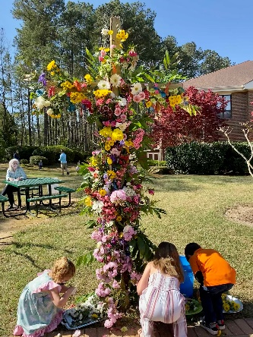

All those factors—big and small—filled me with optimism Easter morning.

Beyond Easter there is reason for even wider optimism:

- There’s medicine: That second dose of the vaccine makes me feel like I’m moving through the world covered in a cloak of invisible protection.
- There’s movement -- we will soon worship in a new way—inside the building—bringing with us all the new things we have become during this last year.
- There’s metamorphosis: Our church continues to find new ways to model Christ in our community, holding VBS outside, offering summer camps for preschoolers, planning a new garden worship space, reworking our structure to more effectively serve as leaders, visionaries, and caretakers.

What does it mean to be optimistic?
Optimism is hope—a faith in things unseen grounded in the goodness that is God’s creation. Optimism is an opening—of heart and of head. It’s abundance, possibility, a cup that runneth over. It’s a big, giant, permanent “can” in the face of “can’t.” It’s mercy in the face of condemnation. It’s grace in the face of shame. It’s a posture of receiving and believing. Optimism is the opposite of closing, confining, isolating, and excluding.

A pessimist, the opposite of an optimist, looks at this glass of water and says, “It’s already half empty.” An optimist looks at this glass and says, “Wow, it’s halfway full!” And an optimist with faith says, “Look, here is water! What is to prevent me from being baptized?” The Ethiopian eunuch we meet in the book of Acts is an optimist with faith.
Optimism doesn’t equal easy. It translates change into opportunity. Possibility. Optimism gives us courage. To take the road less traveled. To invite another to translate meaning for us. To be born anew.
Optimistic faith is essential to the church of Jesus Christ today and 2000 years ago. Here’s how those two very different time periods still connect:

- In Acts 8, the eunuch leaves a place of safety to travel a wilderness road to worship.
- That wilderness road in today’s Georgia might be leaving our position of comfort to listen to previously unheard voices from an unfamiliar place.
- The eunuch was an outsider, an “other” to the Jewish people. He intentionally put himself in a place where he was “other” so he could worship God.
- In today’s Georgia, I seek to follow Christ into spaces where I am “other.” It takes a tremendous amount of faith to loosen one’s grip on a position of power and seek justice for all of God’s people.
- The eunuch followed his faith when the only thing he knew for sure…was that he didn’t know everything.
- In our information-filled world it’s tough to admit we don’t know all the answers. Faithful optimism means asking questions, challenging the status quo, secure in the knowledge that we worship a God of love, justice, and grace.
- The eunuch returned to the same home by the same road but did not return as the same person.
- We too are moving to the sanctuary soon, but like the eunuch, our journey has changed us. Different pews, different leadership, different relationships with one another. And after a year of Covid, we have a changed relationship with the God whom we worship.

“Look, here is water! What is to prevent me from being baptized?” Is this glass of water half empty, half full, or is it a baptismal font?

I want to be the eunuch. He held that scripture which he did not understand—and instead of casting it aside in frustration or embarrassment, he invited a stranger to explain it to him. He sought to expand his mind, to gain insight from God’s word. The eunuch, despite wearing royal robes and being carried on a fancy chariot, took on a posture of receiving. He said to Philip, Pop up here, sit next to me, and tell me how God is calling me to be better and to make the world, God’s kingdom, better.

How will we get to work, to make changes in society, to weave justice into our status quo, to spread the love of Christ beyond the palace, the temple, the back parking lot, the cul-de-sac and into every single life, available to every child of God whom we encounter?
I want to travel bravely on this road through the wilderness. It’s risky, but I know there are important things about God’s kingdom that I need to learn. And I need someone—someone very much unlike me-- to guide me. I need authors like James Cone, James Baldwin, Austin Channing Brown, Ibram X Kendi, Ta-Nehisi Coates, Isabel Wilkerson, Jemar Tisby and Brittney Cooper as conversation partners. I need fellow seekers like the women in my book club and the pastors in my Presbytery anti-racism group who are also stumbling about blindly, willing to engage in challenging conversations so we all can grow. I need to listen. And I need to tap my faithful optimism to get on that wilderness road.

The world is not a palace or a temple or the sanctuary at PHPC. The world is the wilderness road. But we do not travel alone. We travel in and with and through Christ. Christ is not a destination we seek, Christ is the road itself. Jesus said, “I am the way, the truth, and the life.” To follow Christ is to get on that road. To question. To learn. To open our hearts and minds to a wildly optimistic faith. To live as Easter people.

Justice advocate James Baldwin wrote, “I can’t be a pessimist because I am alive. To be a pessimist means that you have agreed that human life is an academic matter. So, I am forced to be an optimist. I am forced to believe that we can survive, whatever we must survive.”

And I would add that because we are Easter people, we seek for all of God’s people to more than survive…we want to see people THRIVE.

I felt optimistic on Easter morning. I hope you did too. And I hope you’re still feeling it.

This glass is not half empty. This glass is not half full. This is a baptismal font. And ahead is a big road through the wilderness. Let’s get soaking wet and let’s hit the road.

Amen.

Diana Butler Bass, Freeing Jesus, New York: Harper Collins, 2021, p. 194.
James Baldwin is quoted by Dante Stewart on Instagram, April 28, 2021.

